**Determine sentiment of text**

Sentiment analysis and opinion mining are two ways of detecting positive and negative sentiment. Using sentiment analysis, you can get sentiment labels (such as "negative", "neutral" and "positive") and confidence scores at the sentence and document-level. Opinion Mining provides granular information about the opinions related to words (such as the attributes of products or services) in the text.

**Sentiment Analysis**

Sentiment Analysis applies sentiment labels to text, which are returned at a sentence and document level, with a confidence score for each.

The labels are *positive*, *negative*, and *neutral*. At the document level, the *mixed* sentiment label also can be returned. The sentiment of the document is determined below:

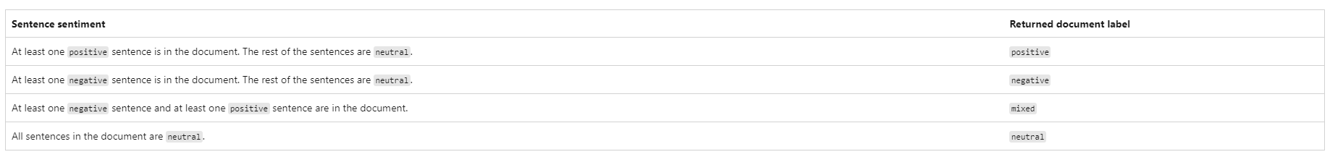

Confidence scores range from 1 to 0. Scores closer to 1 indicate a higher confidence in the label's classification, while lower scores indicate lower confidence. For each document or each sentence, the predicted scores associated with the labels (positive, negative, and neutral) add up to 1.

**Opinion Mining**

Opinion Mining is a feature of Sentiment Analysis. Also known as Aspect-based Sentiment Analysis in Natural Language Processing (NLP), this feature provides more granular information about the opinions related to attributes of products or services in text. The API surfaces opinions as a target (noun or verb) and an assessment (adjective).

For example, if a customer leaves feedback about a hotel such as "The room was great, but the staff was unfriendly.", Opinion Mining will locate targets (aspects) in the text, and their associated assessments (opinions) and sentiments. Sentiment Analysis might only report a negative sentiment.

[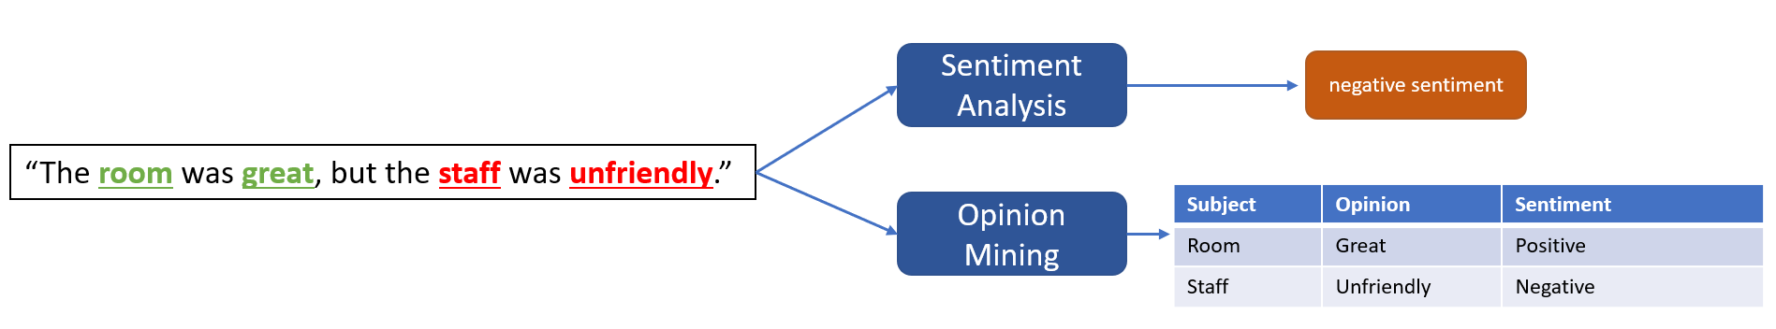](https://learn.microsoft.com/en-us/azure/ai-services/language-service/sentiment-opinion-mining/media/opinion-mining.png#lightbox)

If you're using the REST API, to get Opinion Mining in your results, you must include the **opinionMining=true** flag in a request for sentiment analysis. The Opinion Mining results will be included in the sentiment analysis response. Opinion mining is an extension of Sentiment Analysis and is included in your current [pricing tier](https://azure.microsoft.com/pricing/details/cognitive-services/text-analytics/).

**Development options**

To use sentiment analysis, you submit raw unstructured text for analysis and handle the API output in your application. Analysis is performed as-is, with no additional customization to the model used on your data. There are two ways to use sentiment analysis:



**using the client library and REST API**

**Create an Azure resource**

To use the code sample below, you'll need to deploy an Azure resource. This resource will contain a key and endpoint you'll use to authenticate the API calls you send to the Language service.

1. Use the following link to [create a language resource](https://portal.azure.com/#create/Microsoft.CognitiveServicesTextAnalytics) using the Azure portal. You will need to sign in using your Azure subscription.
2. On the **Select additional features** screen that appears, select **Continue to create your resource**.

[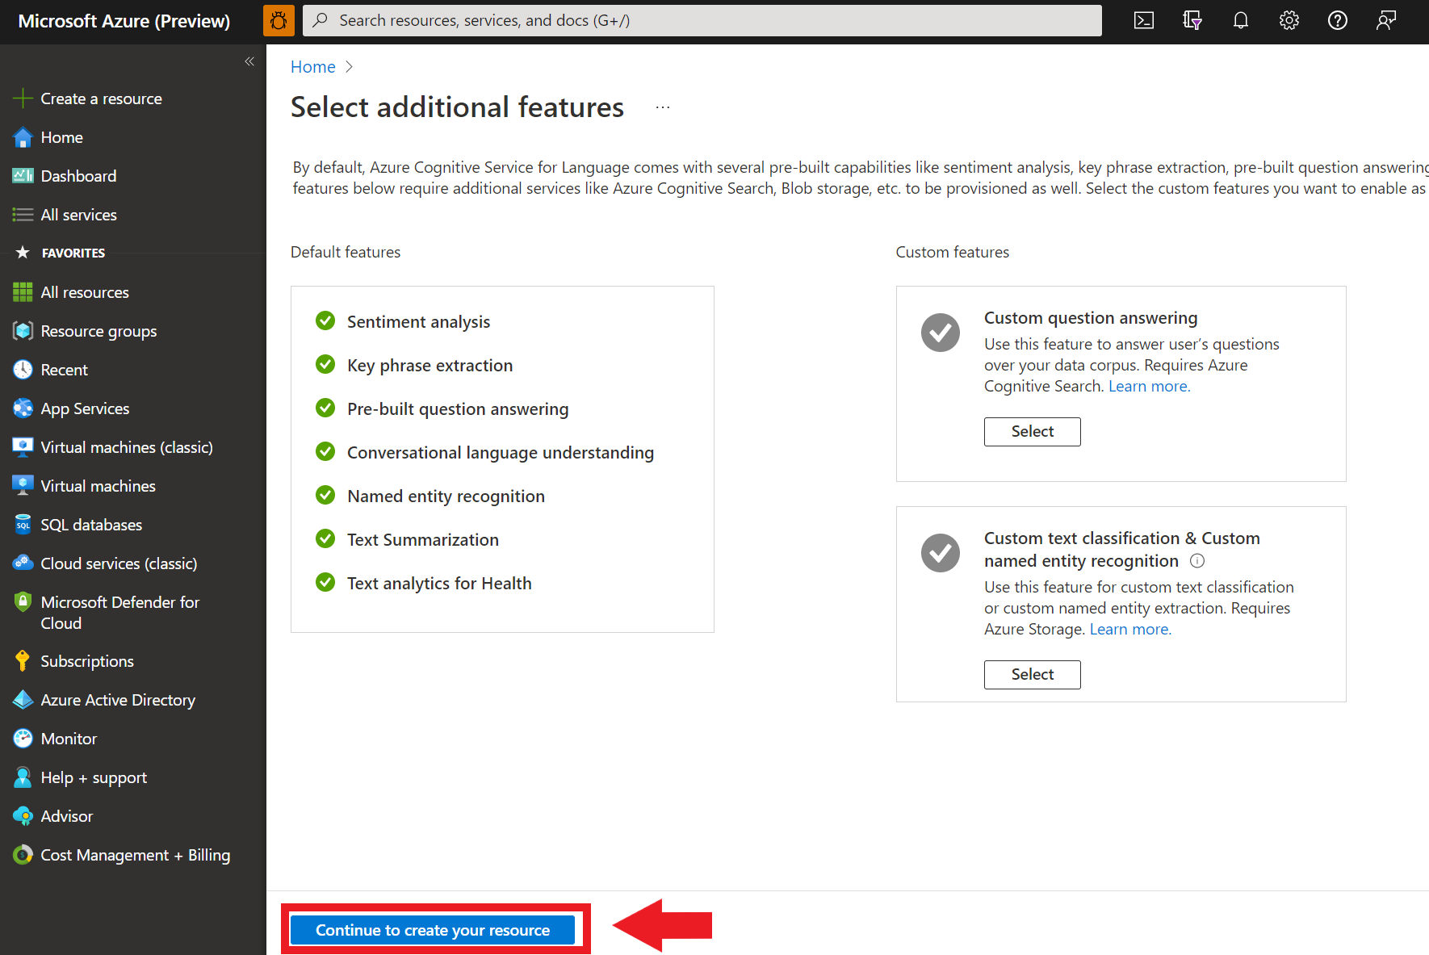](https://learn.microsoft.com/en-us/azure/ai-services/language-service/media/portal-resource-additional-features.png#lightbox)

1. In the **Create language** screen, provide the following information:

[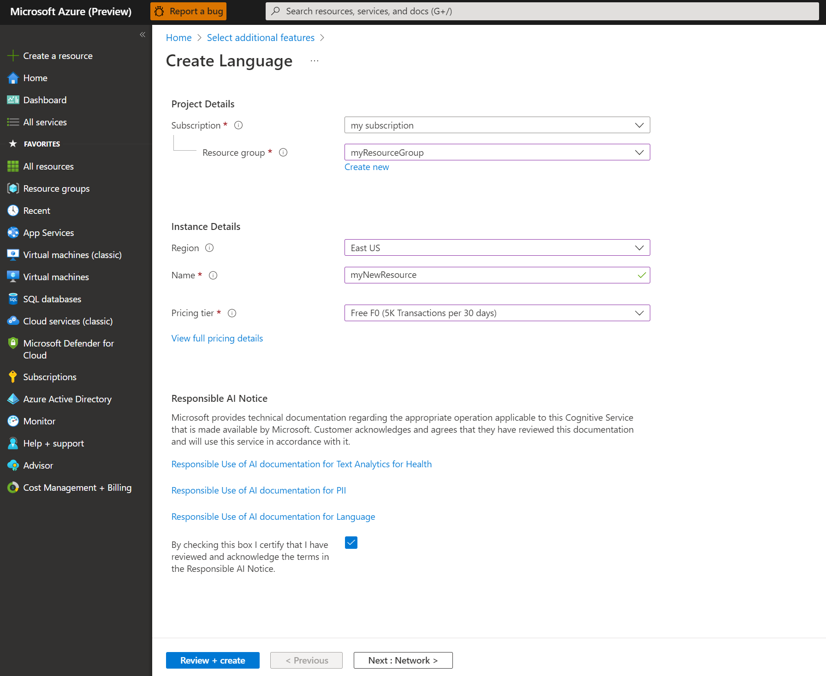](https://learn.microsoft.com/en-us/azure/ai-services/language-service/media/portal-resource-creation-details.png#lightbox)

1. Make sure the **Responsible AI Notice** checkbox is checked.
2. Select **Review + Create** at the bottom of the page.
3. In the screen that appears, make sure the validation has passed, and that you entered your information correctly. Then select **Create**.

**Get your key and endpoint**

Next you will need the key and endpoint from the resource to connect your application to the API. You'll paste your key and endpoint into the code later in the quickstart.

1. After the Language resource deploys successfully, click the **Go to Resource** button under **Next Steps**.

[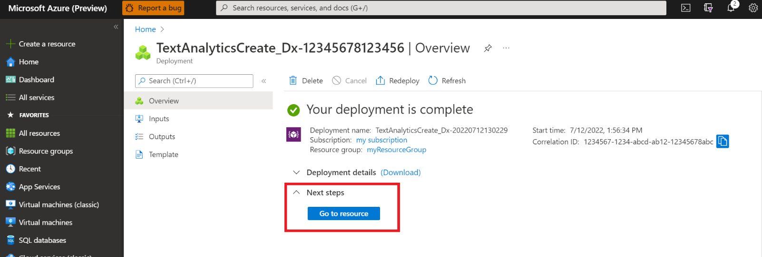](https://learn.microsoft.com/en-us/azure/ai-services/language-service/media/portal-resource-next-steps.png#lightbox)

1. On the screen for your resource, select **Keys and endpoint** on the left navigation menu. You will use one of your keys and your endpoint in the steps below.

[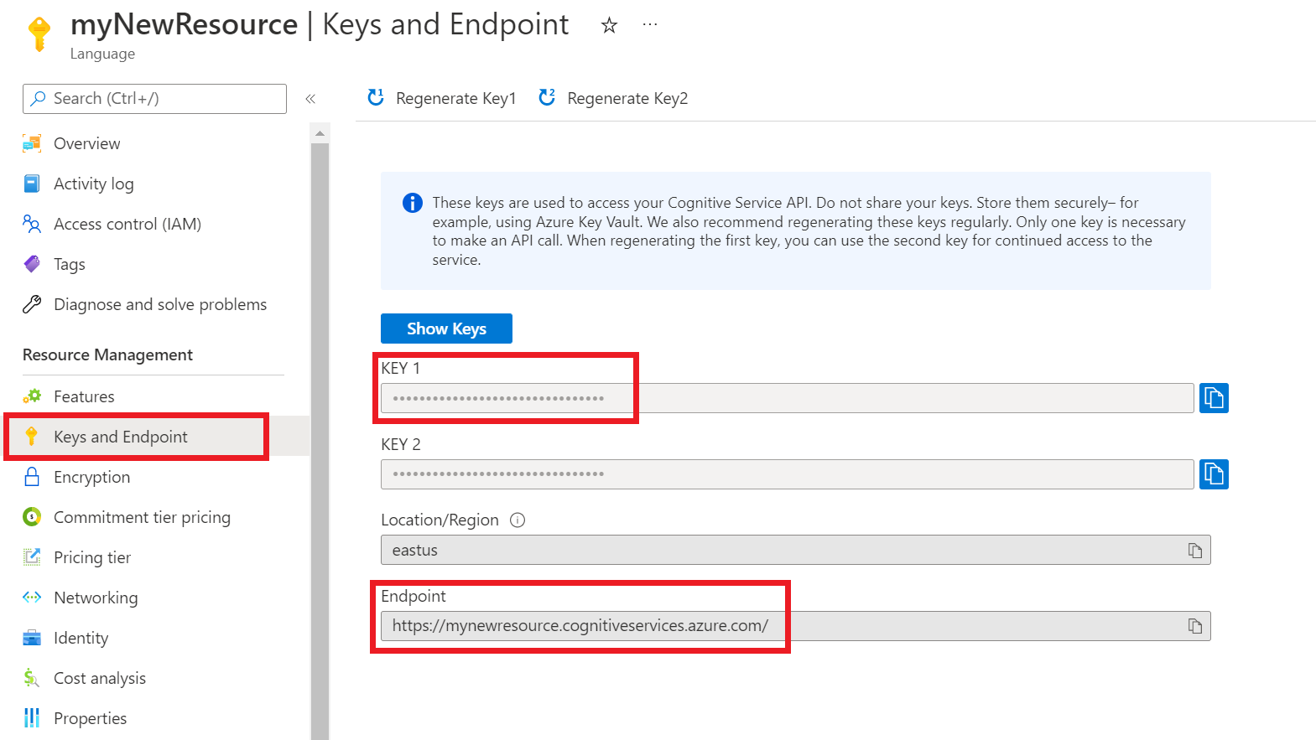](https://learn.microsoft.com/en-us/azure/ai-services/language-service/media/azure-portal-resource-credentials.png#lightbox)

**Create a new .NET Core application**

Using the Visual Studio IDE, create a new .NET Core console app. This creates a "Hello World" project with a single C# source file: *program.cs*.

Install the client library by right-clicking on the solution in the Solution Explorer and selecting Manage NuGet Packages. In the package manager that opens select Browse and search for Azure.AI.TextAnalytics. Select version 5.2.0, and then Install. You can also use the [Package Manager Console](https://learn.microsoft.com/en-us/nuget/consume-packages/install-use-packages-powershell#find-and-install-a-package).

**Code example**

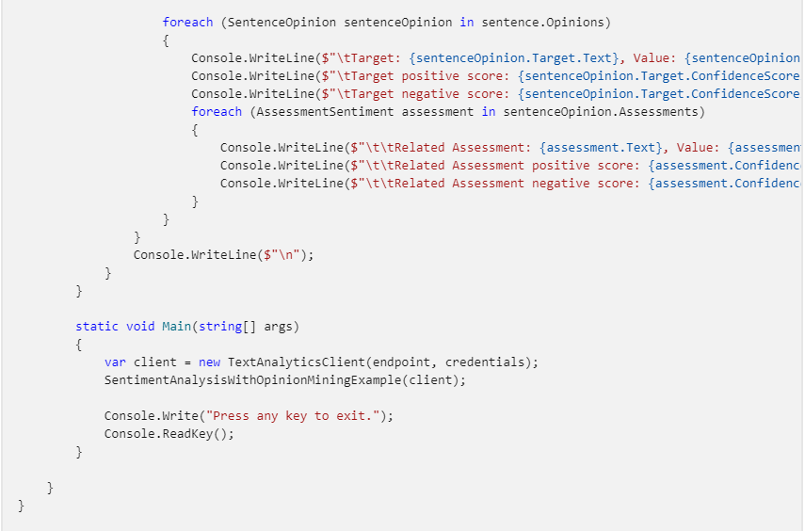

**Output**

**Use Language Studio with your own text**



